[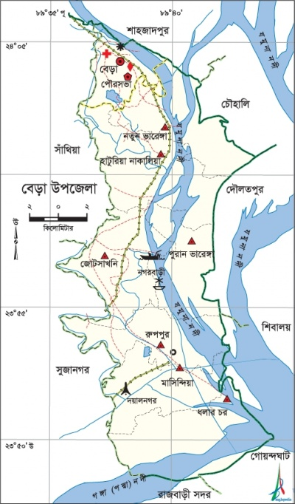](http://bn.banglapedia.org/index.php/%E0%A6%9A%E0%A6%BF%E0%A6%A4%E0%A7%8D%E0%A6%B0:BeraUpazila.jpg)