Upazila Governance and Development Project (UGDP)
Nandigram
Bogura
Rajshahi
Division: District: Upazila:
Best Capacity Development Project
Sub-project Category:
4th
CD-2019-20-501067-03 qqqqqqqqqqqqqqqqqqqqqqqqqqqqqqqqqqqqqqqqqqqqqqqqqqqqqqqqqqqqqqqqqqqqqqqqqqqqqqqqqqqqqqqqqqqqqqqqqqqqqqqqqqqqqqqqqqqqqqqqqqqqqqqqqq
Project ID: Round:
Training on electrical house wiring qwrwiring qqqqqqqqqqqqqqqqqqqqqqqqqqqqqqqqqqqqqqqqqqqqqqqqqqqqqqqqqqqqqqqqqqqqqqqqqqqqqqqqqqqqqqqqqqqqqqqqqqqqqqqqqqqqqqqqqqqqqqqqqqqqqqqqqq
Sub-project Name:
Unemployed Youth
Type of Beneficiaries:
Department of Social Service
Govt. Line Department Involved:

Sub-Project Description
Sub-Project context: Problem/situation | Nandigram is a backward upazila and most of the people of this upazila are depend on agriculture. As a result, unemployment are very common here. They are neglected in the family and society due to unemployment. If we can provide them with skill development training on electrical house wiring, they will be able to earn a living and play a role in the family and society.
Who proposed (Source of activity proposal) and what had been proposed? | The Upazila Social Service Officer raise the training proposal at the Upazila Committee meeting.
What actions were taken from the Upazila Parishad to solve the problem? | Project Selection Committee (PSC) feels that the need for self-employment is more important in the current context. As a result the project selection committee raise the proposal at its monthly meeting, recommending approval. The Upazila Parishad realize that implementation of this project will reduce unemployment and increase people’s income.so the Upazila parishad decides to approve the project.
What will be achieved as a result of the sub-project implementation (Purpose / Objectives? | At the end of the training the trainees will be able to acquire skills in electrical house wiring. They will be able to arrange employment and earn.
What are the output, effect and impact of the sub project? | Twenty number of trainee of the sub project train up for electrical house wiring and the trainees are capable enough to do this well. On the other hand, most of the trainees take electrical house wiring as a profession. As a result, they are playing a leading role in the family, society and state by earning money through this profession.
Good Practices identified | The house wiring profession requires very little capital. This technical training, in a few days any unemployed youth can take up this profession from their area as a means employment and gain financially. Their financial change is comparatively measurable.
What are the Lessons Learned from this sub-project | If the unemployed can be trained technically, they will become an assets, not a burden to the family, society and the state.
Comments/Quotations from the stakeholders | - If UGDP encourages local resources as well as opportunities to bring in established resources from outside, trainees will encouraged to take up this job as a profession through exchange of experience (Upz Parishad  - Training on electrical house wiring should arrange more batch (NBD)  - This training will free us from the curse of unemployment and help us to live with dignity in society (Trainee)
Any linkage with other CD/INF Sub Projects | If this trainees are given all the house wiring activities in the UGDP project, they will soon be known as electricians.

Photographs: (Before, During and After)
Before the Sub-Project | During Implementation of Sub-Project
 | 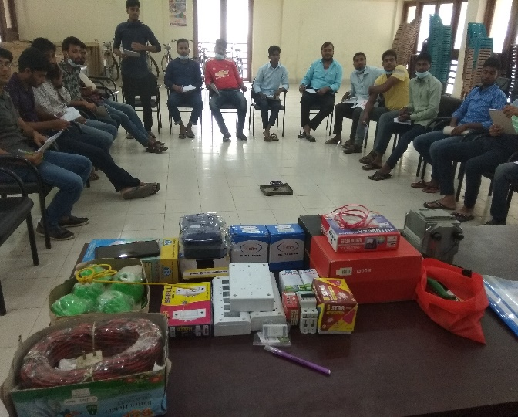
Description of the Photo | Practical Session at training period

During Implementation of Sub-Project | Results/Benefits of Sub-Project
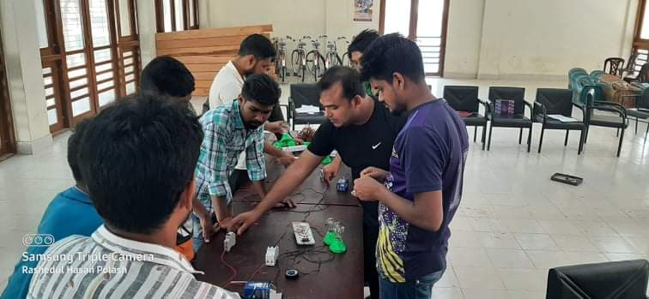 | 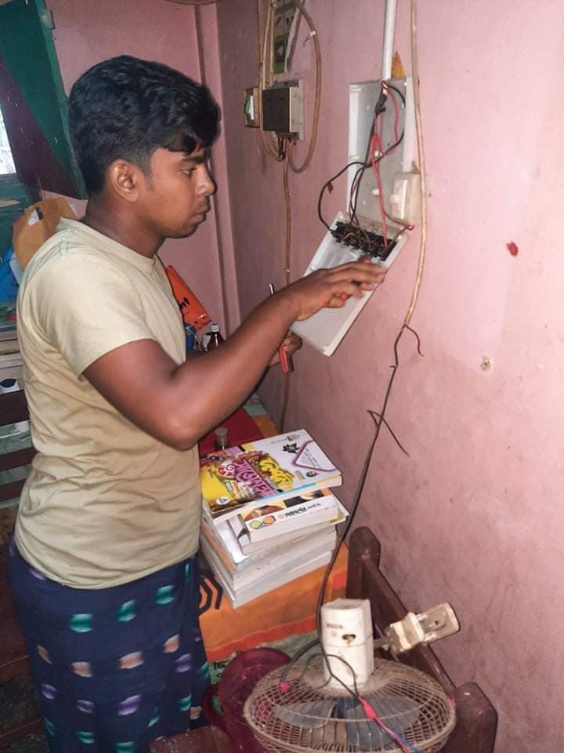
Practical Session at training period | Working at home on a wage basis

Samiul Hoque
Upazila Development Facilitator (UDF)
Nandigram, Bogura

